|  |  |  |  |
| --- | --- | --- | --- |
| **Formulario_Facturar_Compra** | | | |
| Botones | Funciona correctamente | No funciona correctamente | Detalle de errores |
| Btn nuevo | ✓ |  |  |
| Btn eliminar |  | ✓ | No elimina los datos en el datagriw view |
| Btn agregar | ✓ |  |  |
| Btn buscar usuario | ✓ |  |  |
| Btn buscar proveedor | ✓ |  |  |
| Btn facturar | ✓ |  |  |
| Btn cancelar | ✓ |  |  |
| Btn agregar producto | ✓ |  |  |
| Btn crear nuevo producto | ✓ |  |  |

|  |  |  |  |
| --- | --- | --- | --- |
| **Formulario_Facturar_Compra** | | | |
| Combobox | Funciona correctamente | No funciona correctamente | Detalles de errores |
| Combobox estado | ✓ |  |  |

|  |  |  |  |
| --- | --- | --- | --- |
| **Formulario_Facturar_Compra** | | | |
| Radio Button | Funciona correctamente | No funciona correctamente | Funciona correctamente |
| Radio Button efectivo | ✓ |  |  |
| Radio Button tarjeta | ✓ |  |  |

|  |  |  |  |
| --- | --- | --- | --- |
| **Formulario_Facturar_Compra** | | | |
| Data gried view | Funciona correctamente | No funciona correctamente | Detalles de errores |
| Data gried compra | ✓ |  |  |

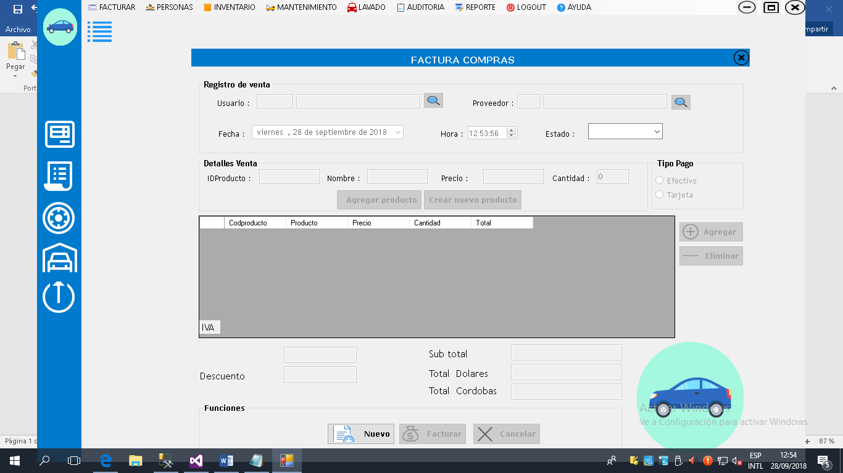

|  |  |  |  |
| --- | --- | --- | --- |
| **Formulario_facturar_Compra_Productos** | | | |
| Radio button | Funciona correctamente | No funciona correctamente | Detalles de errores |
| Radio button inactivo | ✓ |  |  |
| Radio button activo | ✓ |  |  |

|  |  |  |  |
| --- | --- | --- | --- |
| **Formulario_facturar_Compra_Productos** | | | |
| Botones | Funciona correctamente | No funciona correctamente | Detalles de errores |
| Btn nuevo | ✓ |  |  |
| Btn buscar | ✓ |  |  |
| Btn guardar | ✓ |  |  |
| Btn modificar | ✓ |  |  |
| Btn cancelar | ✓ |  |  |
| Btn salir | ✓ |  |  |

|  |  |  |  |
| --- | --- | --- | --- |
| **Formulario_facturar_Compra_Productos** | | | |
| Data gried view | Funciona correctamente | No funciona correctamente | Detalles de errores |
| Data gried Producto | ✓ |  |  |
|  |  |  |  |

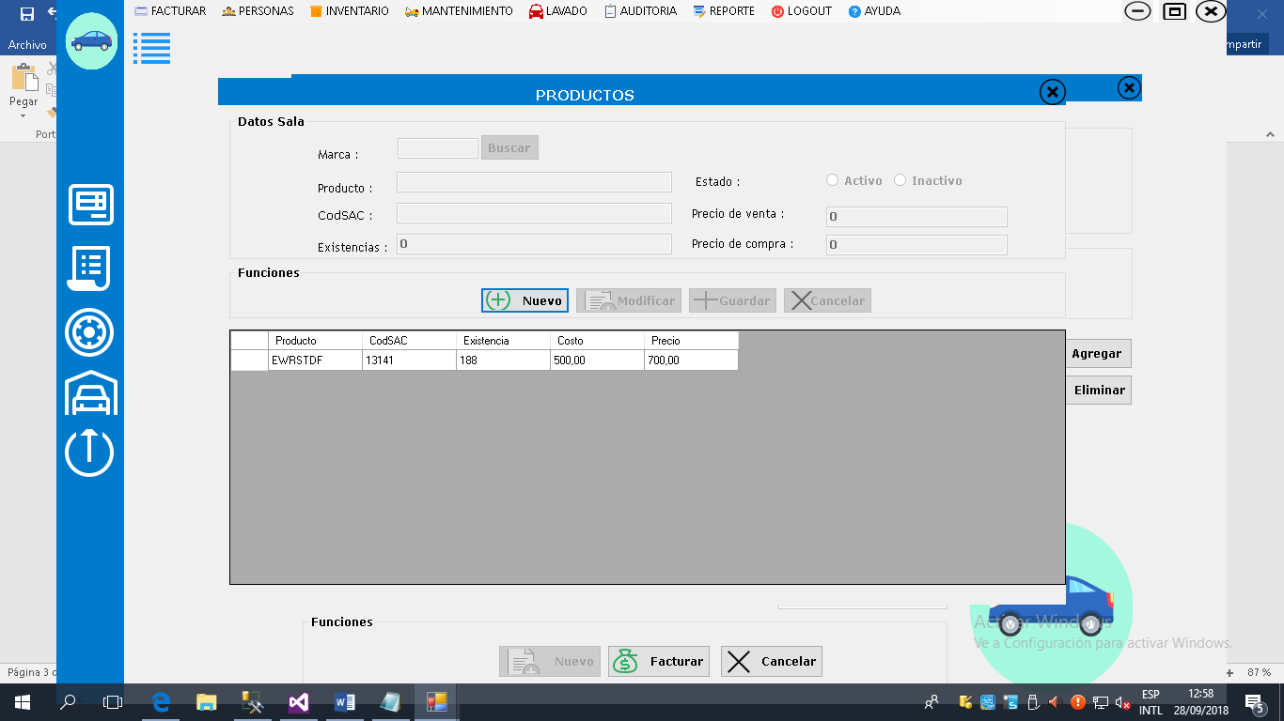

|  |  |  |  |
| --- | --- | --- | --- |
| **Formulario_facturar_Compra_Buscar producto** | | | |
| Radio button | Funciona correctamente | No funciona correctamente | Detalles de errores |
| Radio button código | ✓ |  |  |
| Radio button nombre | ✓ |  |  |

|  |  |  |  |
| --- | --- | --- | --- |
| **Formulario_facturar_Compra_Buscar Producto** | | | |
| Data gried view | Funciona correctamente | No funciona correctamente | Detalles de errores |
| Data gried buscar producto | ✓ |  |  |
|  |  |  |  |

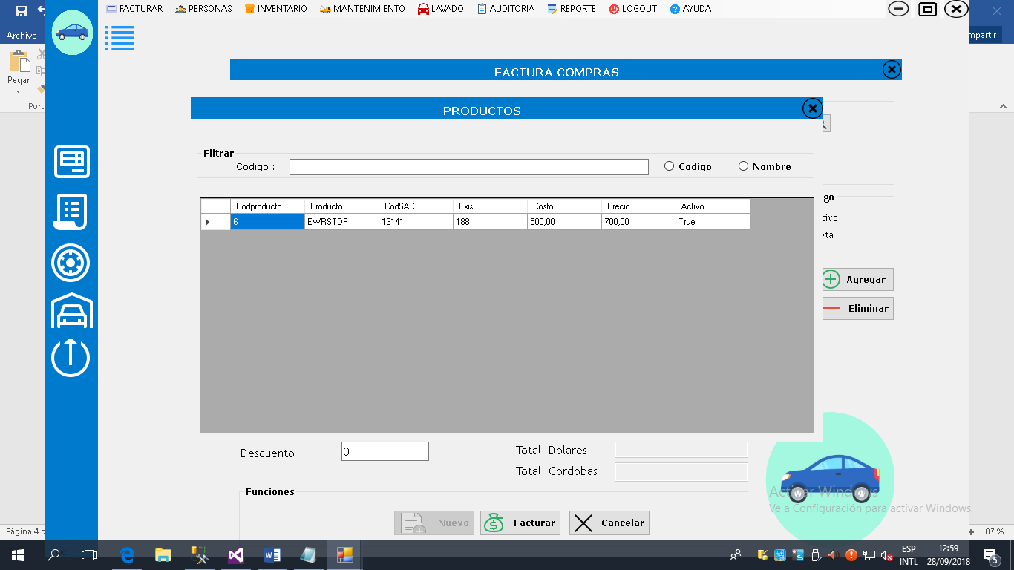

|  |  |  |  |
| --- | --- | --- | --- |
| **Formulario_Facturar_Venta** | | | |
| Botones | Funciona correctamente | No funciona correctamente | Detalles de errores |
| Btn buscar usuario | ✓ |  |  |
| Btn buscar cliente | ✓ |  |  |
| Btn agregar | ✓ |  |  |
| Btn nuevo | ✓ |  |  |
| Btn facturar | ✓ |  |  |
| Btn cancelar | ✓ |  |  |
| Btn agregar producto | ✓ |  |  |
| Btn eliminar | ✓ |  |  |
| Btn salir | ✓ |  |  |

|  |  |  |  |
| --- | --- | --- | --- |
| **Formulario_Facturar_Venta** | | | |
| Combobox | Funciona correctamente | No funciona correctamente | Detalles de errores |
| Combobox estado | ✓ |  |  |

|  |  |  |  |
| --- | --- | --- | --- |
| **Formulario_Facturar_Venta** | | | |
| Radio Button | Funciona correctamente | No funciona correctamente | Funciona correctamente |
| Radio Button efectivo | ✓ |  |  |
| Radio Button tarjeta | ✓ |  |  |

|  |  |  |  |
| --- | --- | --- | --- |
| **Formulario_Facturar_Venta** | | | |
| Data gried view | Funciona correctamente | No funciona correctamente | Detalles de errores |
| Data gried Venta | ✓ |  |  |

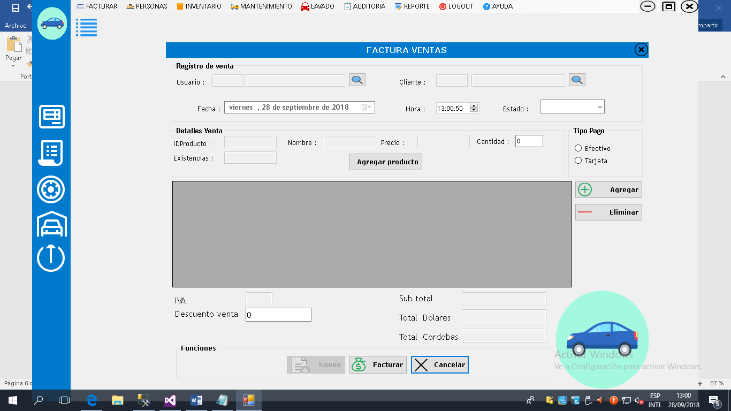

|  |  |  |  |
| --- | --- | --- | --- |
| **Formulario_facturar_Venta_Buscar producto** | | | |
| Radio button | Funciona correctamente | No funciona correctamente | Detalles de errores |
| Radio button código | ✓ |  |  |
| Radio button nombre | ✓ |  |  |

|  |  |  |  |
| --- | --- | --- | --- |
| **Formulario_facturar_Venta_Buscar Producto** | | | |
| Data gried view | Funciona correctamente | No funciona correctamente | Detalles de errores |
| Data gried buscar producto | ✓ |  |  |
|  |  |  |  |

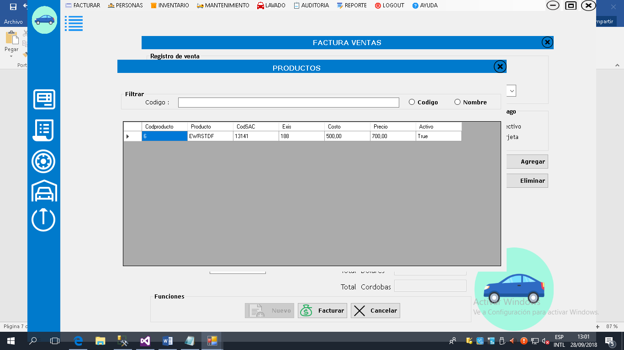

|  |  |  |  |
| --- | --- | --- | --- |
| **Formulario_Facturar_Devolucion_Compra** | | | |
| Botones | Funciona correctamente | No funciona correctamente | Detalles de errores |
| Btn buscar facturas | ✓ |  |  |
| Btn guardar devolución | ✓ |  |  |
| Btn cancelar | ✓ |  |  |
| Btn salir | ✓ |  |  |

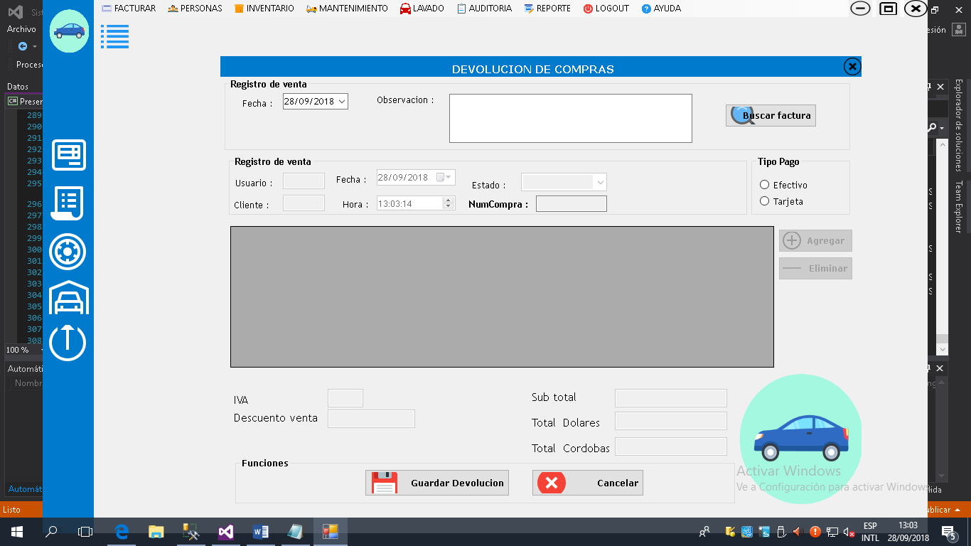

|  |  |  |  |
| --- | --- | --- | --- |
| **Formulario_Facturar_** **Devolucion_Compra _Buscar Facturas** | | | |
| Radio button | Funciona correctamente | No funciona correctamente | Detalles de errores |
| Radio button código | ✓ |  |  |

|  |  |  |  |
| --- | --- | --- | --- |
| **Formulario_facturar_ Devolucion_Compra _Buscar Producto** | | | |
| Data gried view | Funciona correctamente | No funciona correctamente | Detalles de errores |
| Data gried buscar facturas | ✓ |  |  |

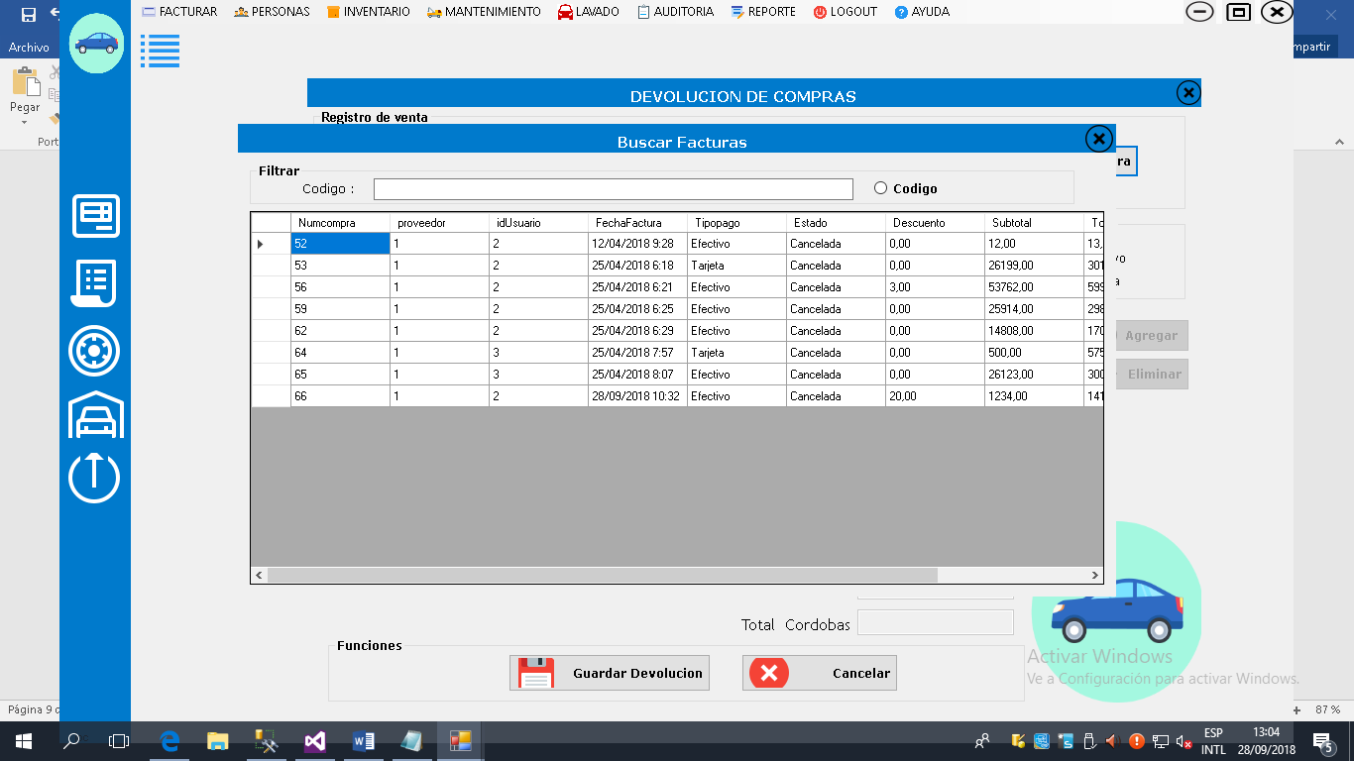

**Facturar devolución venta**

|  |  |  |  |
| --- | --- | --- | --- |
| **Formulario_Facturar_Devolucion_Venta** | | | |
| Botones | Funciona correctamente | No funciona correctamente | Detalles de errores |
| Btn buscar factura | ✓ |  |  |
| Btn guardar devolución | ✓ |  |  |
| Btn cancelar | ✓ |  |  |
| Btn salir | ✓ |  |  |

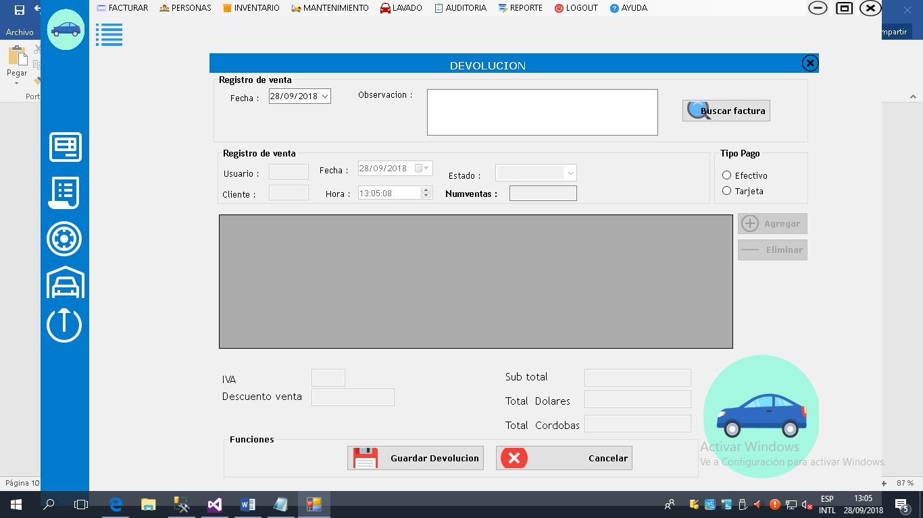

|  |  |  |  |
| --- | --- | --- | --- |
| **Formulario_Facturar_** **Devolucion_Venta _Buscar Facturas** | | | |
| Radio button | Funciona correctamente | No funciona correctamente | Detalles de errores |
| Radio button código | ✓ |  |  |
| Radio button cliente | ✓ |  |  |

|  |  |  |  |
| --- | --- | --- | --- |
| **Formulario_facturar_ Devolucion_Venta _Buscar Facturas** | | | |
| Data gried view | Funciona correctamente | No funciona correctamente | Detalles de errores |
| Data gried buscar facturas | ✓ |  |  |

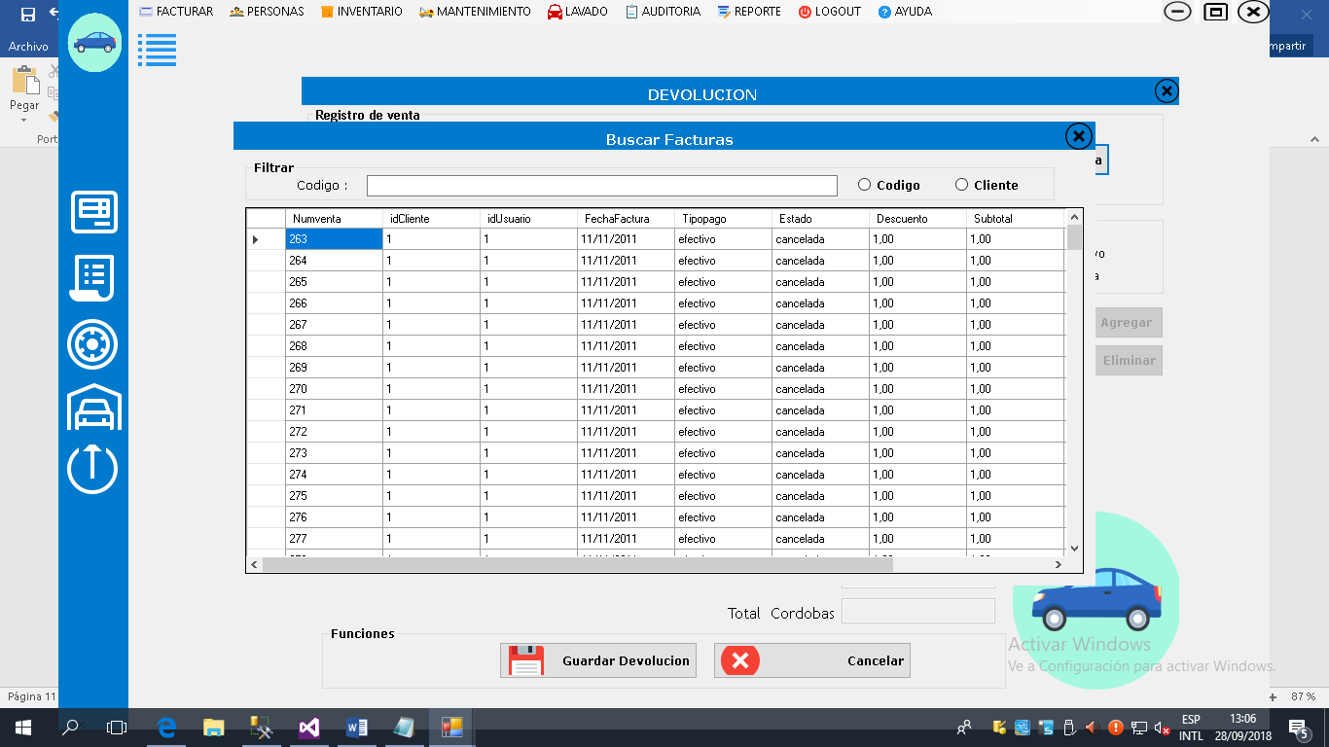

**Lavado Lavado de vehículo**

|  |  |  |  |
| --- | --- | --- | --- |
| **Formulario_Lavado_Lavado de Vehículo** | | | |
| Botones | Funciona correctamente | No funciona correctamente | Detalles de errores |
| Btn buscar servicio | ✓ |  |  |
| Btn buscar vehículo | ✓ |  |  |
| Btn nuevo | ✓ |  |  |
| Btn modificar | ✓ |  |  |
| Btn guardar | ✓ |  |  |
| Btn cancelar | ✓ |  |  |
| Btn salir | ✓ |  |  |

|  |  |  |  |
| --- | --- | --- | --- |
| **Formulario_ Lavado_Lavado de Vehículo** | | | |
| Data gried view | Funciona correctamente | No funciona correctamente | Detalles de errores |
| Data gried buscar vehículos lavados | ✓ |  |  |

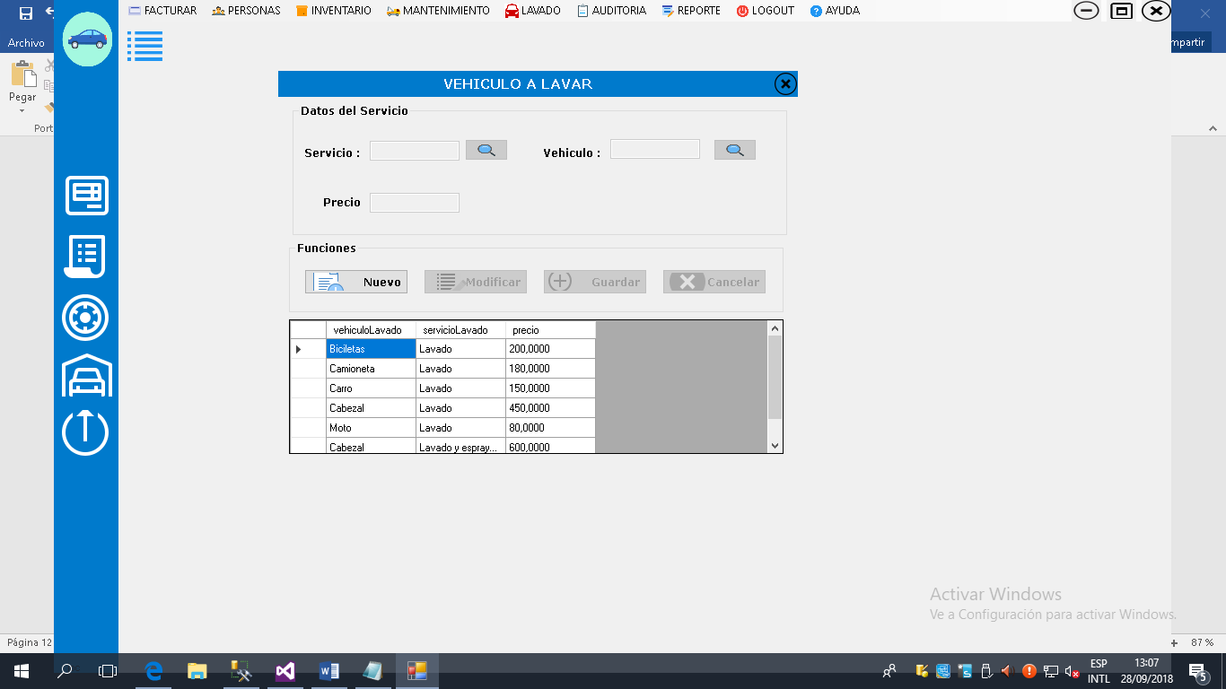

|  |  |  |  |
| --- | --- | --- | --- |
| **Formulario_Lavado_Vehiculos** | | | |
| Botones | Funciona correctamente | No funciona correctamente | Detalles de errores |
| Btn nuevo | ✓ |  |  |
| Btn modificar | ✓ |  |  |
| Btn guardar | ✓ |  |  |
| Btn cancelar | ✓ |  |  |
| Btn salir | ✓ |  |  |

**Formulario de lavado Vehiculos**

|  |  |  |  |
| --- | --- | --- | --- |
| **Formulario_ Lavado_ Vehículos** | | | |
| Radio button | Funciona correctamente | No funciona correctamente | Detalles de errores |
| Radio button inactivo | ✓ |  |  |
| Radio button activo | ✓ |  |  |

|  |  |  |  |
| --- | --- | --- | --- |
| **Formulario_ Lavado_ Vehículos** | | | |
| Data gried view | Funciona correctamente | No funciona correctamente | Detalles de errores |
| Data gried tipos de vehículos | ✓ |  |  |

